Accessibility Plan

January 2016 – December 2019
Submitted to St. Joseph’s Accessibility Advisory Committee December 24, 2015
Submitted to St. Joseph’s Senior Leadership Team January 26, 2016

Introduction
In fulfilling our mission and in alignment with our values of respect, compassion and excellence, St. Joseph’s Health Care London (St. Joseph’s) strives to provide accessible care in a manner that respects the dignity and independence of people with disabilities. St. Joseph’s is also committed to ensuring that all patients have an equal opportunity to obtain, use, and benefit from our programs and services.

St. Joseph’s is committed to continual improvement of facilities access, policies, programs, practices and services for patients and their family members, staff members, health care practitioners, volunteers and members of the community with disabilities; the participation of people with disabilities in the development and review of its accessibility plan; and the provision of quality services to patients and their family members and members of the community with disabilities.

In compliance with the Ontarians with Disabilities Act (ODA) and the Accessibility for Ontarians with Disabilities Act’s (AODA) Customer Service Standards and Integrated Accessibility Standards, a multi-year accessibility plan was prepared and approved for 2016-2019 (inclusive). Public sector organizations are obligated under the Integrated Accessibility Standard to prepare annual status reports that indicate the progress of measures underway to address barriers. Past plans and status reports are available on St. Joseph’s public website.

St. Joseph’s Health Care, London
St. Joseph’s Health Care London is a major patient care, teaching and research centre. It is owned and operated by the St. Joseph’s Health Care Society, incorporated and governed by a volunteer board of directors from our community. With its founding organizations, St. Joseph’s has a distinguished legacy of services to London and Southwestern Ontario and to the veterans of Canada.
St. Joseph's:
- Is one of Ontario's 14 academic hospitals
- Has approximately 4,000 employees, 2,000 physicians with primary appointment city-wide and 1,100 volunteers
- Is comprised of: St. Joseph's Hospital, Parkwood Institute, Southwest Centre for Forensic Mental Health Care, Mount Hope Centre for Long Term Care, Family Medical and Dental Centre and 11 team and service locations across the region.
- Has facilities square footage totaling: 3,217,223
- Plays major roles in: day and short stay surgery; complex chronic disease management; specialized mental health care; rehabilitation; complex continuing care; palliative care; long term care; and veterans care
- Is affiliated with Western University, provides student learning experiences for more than 2,000 people from colleges and universities around the world each year

The Accessibility Advisory Committee
The Accessibility Advisory Committee is accountable to the Senior Leadership Team via the Vice President of Patient Care and Quality. The committee draws staff members from across the sites with varied roles as well as community members and a resident of the Parkwood Institute. Some members of the working group have disabilities while other members work directly with patients and staff members who have disabilities.

Planning Cycle
In years that a plan is not created, an annual status report is prepared at the end of the calendar year for submission to the Senior Leadership Team. The term of each multi-year plan is determined by the Accessibility Advisory Committee.

Accessibility Compliance Report
St. Joseph’s Accessibility Compliance Report was completed and submitted to the Accessibility Directorate of Ontario. Designated as a large designated public sector organization, St. Joseph’s is required to file online reports with the Accessibility Directorate, which falls under the Ministry of Economic Development, Trade and Employment. The next report is required by December 31, 2017. The report requires St. Joseph’s to respond to questions regarding compliance with the Customer Service and Integrated Accessibility Standards.

Accessibility Plan 2016-2019

Accessibility Plan Consultations
The purpose of the consultations was to identify barriers patient, visitors and staff encounter when accessing care, service or employment at St. Joseph’s. Presentations were provided and input was received from the following councils:
- Mount Hope Family Council
- Mental Health Family Council
- Veterans Resident Council
- St. Joseph’s Patient Council

Input from St. Joseph’s leaders was gained at an organization-wide leaders’ meeting and input was obtained from staff through an online survey. A webpage was constructed to facilitate responses from the community. The Accessibility Advisory Committee received over 100 submissions which is a significant increase from 2013.

Assessment of Barriers
The Accessibility Advisory Committee met twice for several hours to determine the criteria for assessing the submissions and then to assess the barriers against the criteria. At each session, there was at least one community member present. Some of the barriers identified were intentionally designed as safety measures, such as placement and size of keypads used to open doors at Mount Hope; these were not included in the plan as well as barriers that could be immediately addressed. Using the criteria and through discussions, barriers were prioritized, with “1” signifying the highest priority.

Given that there are two new mental health facilities, recent renovations to part of St. Joseph’s Hospital, and the older sites were constructed prior to the launch of the Built Environment Standards; St. Joseph’s Health Care is compliant with the building code and is now aiming to modify areas of the facilities to meet the specific needs of the patient population that uses the facilities.

Work Plan for 2016-2019
A work plan was created based on the Committee’s assessment of barriers, then submitted to the Senior Leadership Team for discussion and approval.

Work Plan

Location | Identified Barrier | Means to prevent or remove barrier
Parkwood Institute Mental Health Care Building - Library | Manual door | Install an automatic door
Parkwood Institute Mental Health Care Building - Health Records | Manual door | Install an automatic door
Parkwood Institute Mental Health Care Building - Health Service Department | Manual door to department | Install an automatic door
Parkwood Institute Mental Health Care Building - Ambulatory Care | Manual door | Install an automatic door
St. Joseph’s Hospital – Foundation Office | Manual door to department | Install an automatic door
St. Joseph’s Hospital Urgent Eye Clinic B1-102A | Washroom requires two support bars | Install a support bar
St. Joseph’s Hospital D1-112b | Washroom support bars not configured appropriately
St. Joseph’s Hospital Cheapside entrance #4 | When revolving doors are out of order, side doors are not wide enough for persons using large wheelchairs | - Provide signage indicating people use D zone automatic sliding doors (located just around the corner and opening to same sidewalk/drive way.  - Contact Volunteer Services, which has a desk beside the entrance doors to guide people using wheelchairs to use D zone doors when revolving door is not working
St. Joseph’s Hospital Rheumatology Clinic D2 101b and D2 188 | Manual doors on men’s and women’s washrooms | Install automatic doors
St. Joseph’s Hospital - HULC | Manual door for washroom | - Install an automatic door  - Redirect patients to the hallway or D3
St. Joseph’s Hospital D0 | Location of two physician offices inaccessible | Move physician offices to accessible areas of the hospital
St. Joseph’s Hospital | No adult change table | Install an adult change table
Parkwood Institute Mental Health Care Building – Occupational Health and Safety Services | Manual door to department | Install an automatic door
Parkwood Institute Mental Health Care Building - Prescription Shop | Manual door to shop | Install an automatic door
Parkwood Institute Main Building - Outpatient Clinic | Chairs are too low and seat is slanted back making it difficult to stand up from sitting | Replace chairs
Parkwood Institute Main Building | Patients use the internet in addition to their alternative access communication systems (AAC); they use Skype, email or Facebook for messages about meeting times, arrange transportation, communicate with family and friends etc. Lack of access to WIFI makes it challenging for  therapists to program AAC devices for patients.. | Issues to be reviewed and strategies developed
Parkwood Institute Main Building - Day Hospital | Sign for Day Hospital is smaller than the previous one | Replace pedestrian sign with driving sign
Mount Hope walk way | Downward slope, railing broken | Railing to be repaired by summer 2016
Parkwood Institute Mental Health Care Building | Uneven sidewalk and curbs in multiple locations | To be repaired by summer 2016
Mount Hope, 21 Grosvenor Street Entrance | Driveway at west end has a significant dip where it abuts the sidewalk, this poses a tripping hazard | To be repaired
Mount Hope | Manual doors on washroom by fish tank | Install automatic doors – requires investigation
St. Marys | French doors to auditorium difficult to open (several sets, some facing the town square and others facing the north corridor) | Install automatic openers on doors facing town square
Mount Hope | Lack of microphones making it difficult for people to participate in Resident and Family Council meetings | Purchase microphones

Initiatives to Improve Accessibility in the Future
The PI Main Building was constructed in the mid-1980s without public washrooms on each floor and without fully accessible public washrooms. In patient rooms washroom are not fully accessible, they are small with narrow doors and awkwardly located plumbing making use of commodes challenging. Currently, some public washrooms located in the central part of the facility contain accessibility features while others are fully accessible. If renovations are contemplated to the common areas in the PI Main Building, it is recommended that nine barrier free unisex washrooms be considered; one on each floor of the Western Counties Wing, one each floor of A pod and one on each floor of B pod. Further, it is recommended that if renovations are undertaken in patient areas, washrooms in patient rooms be remodelled to be accessible.

Marian Villa, an older building within Mount Hope Long Term Care, has inaccessible resident bathrooms that do not accommodate wheelchairs and mechanical lifts. To enhance resident independence by addressing accessibility requirements, it is recommended that if there are renovations or reconstruction, accessibility features be included.

Initiatives to Improve Accessibility
St. Joseph’s continually invests in, and focuses on, mitigating or eliminating barriers to care. The primary focus in 2015 was the opening of a large renovated section of St. Joseph’s Hospital. This area of the hospital boasts many accessibility features such as automatic sliding doors, a wide graded circular drive without steps and curbs, a lobby large enough for those with wheelchairs and walkers to manoeuvre, levered door handles, and large coloured banners with the letter of the area to aid in wayfinding. Photographs of St. Joseph’s Zone A follow:

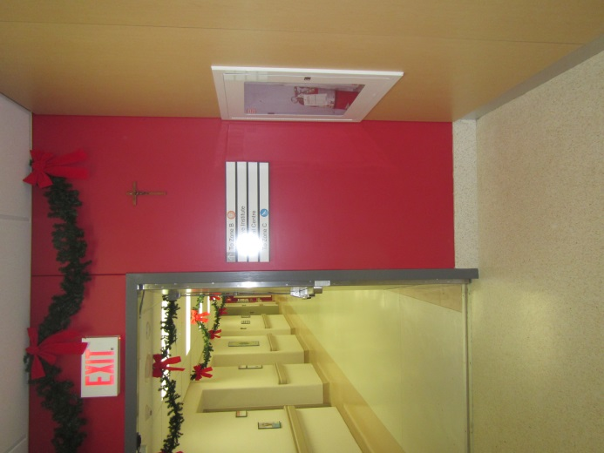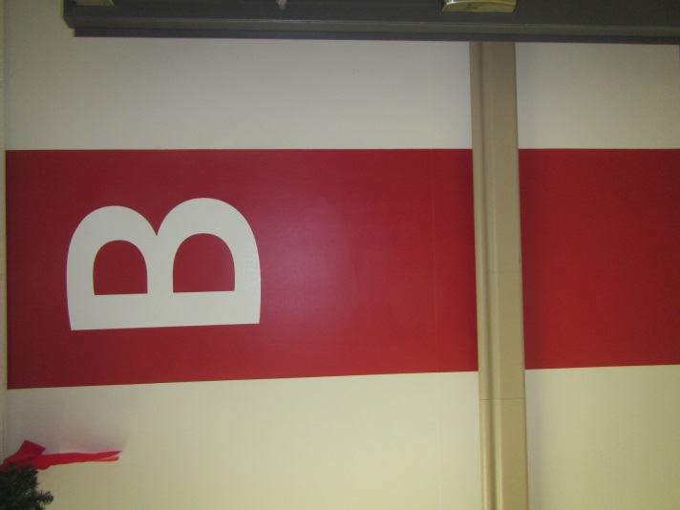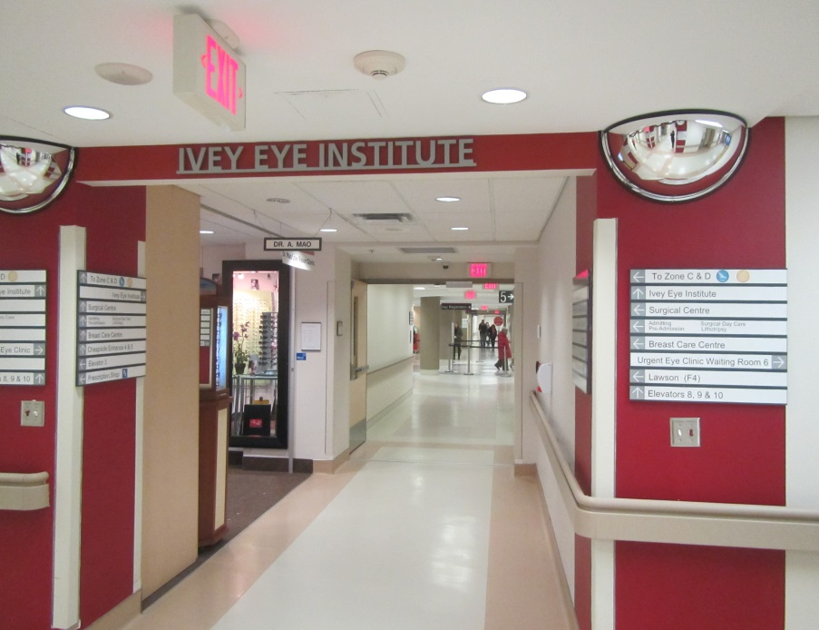

Improved way finding at St. Joseph’s Hospital with colour coded zones and banners indicating the zone.

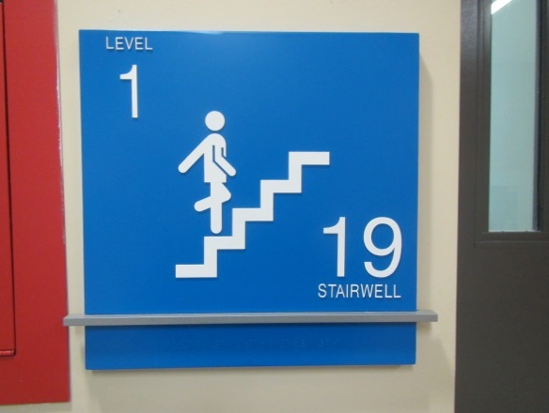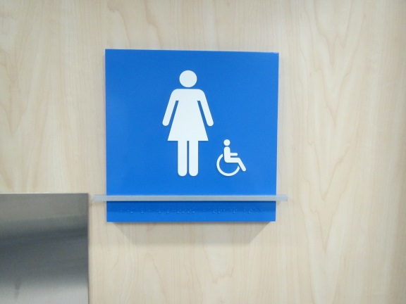
- High contrast signs with braille (under the raised silver bar)
- Raised symbols and letters

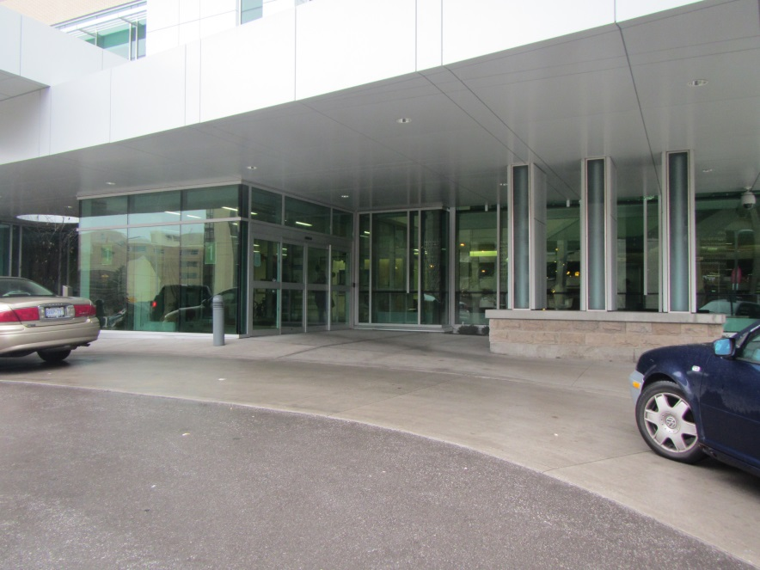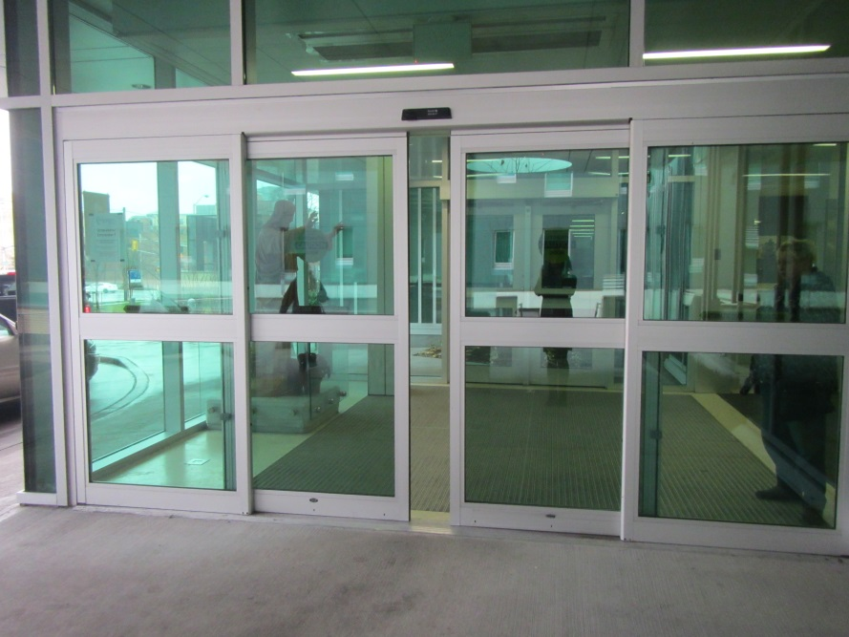
- Large accessible entrance with graded pavement (no curbs or steps)
- Wide sliding automatic doors
- Covered waiting area

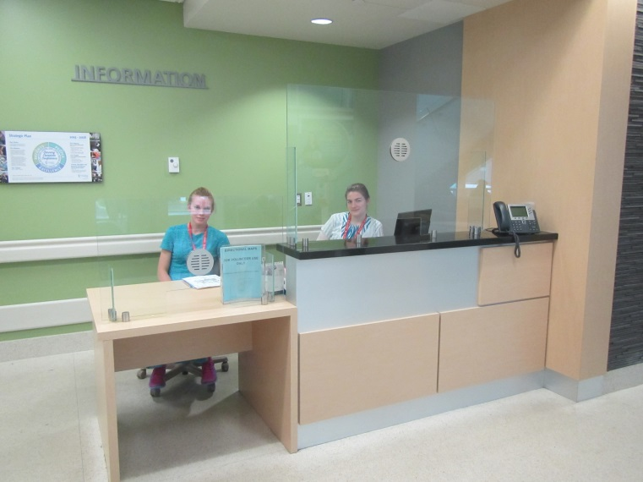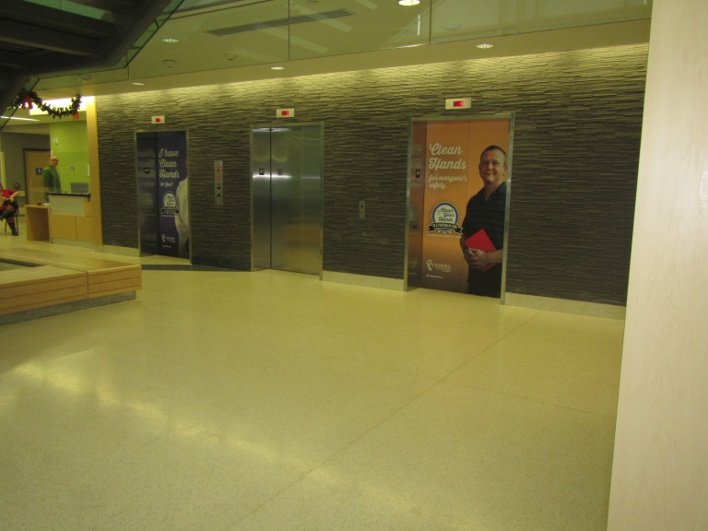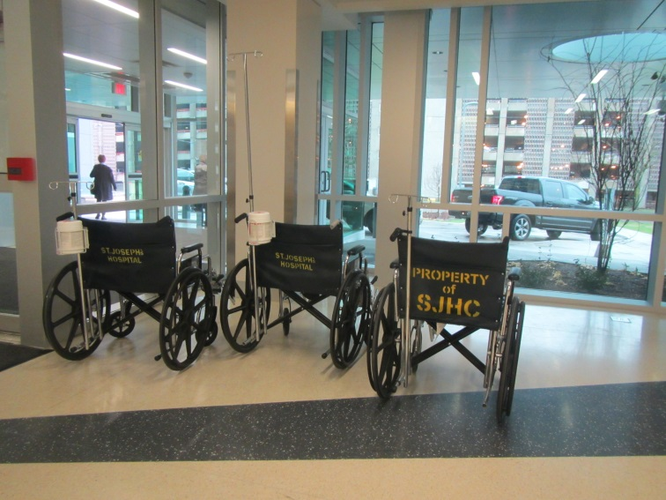
- Large open lobby to facilitate manoeuvrability for those using wheelchairs or walkers
- Abundant natural light
- Information desk accommodates people using wheelchairs
- Wheelchairs readily available just inside the entrance
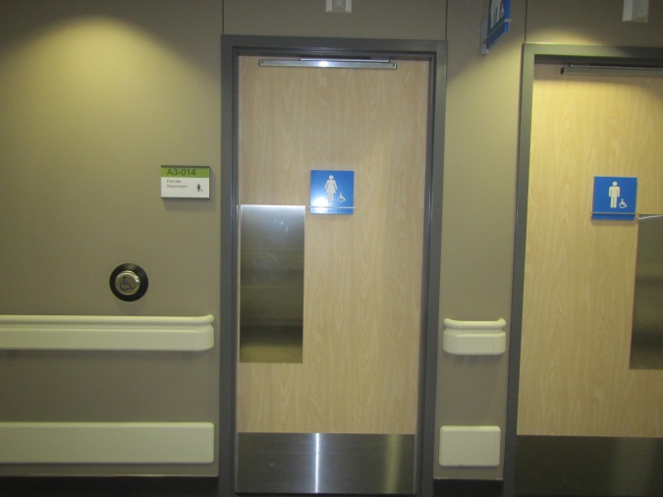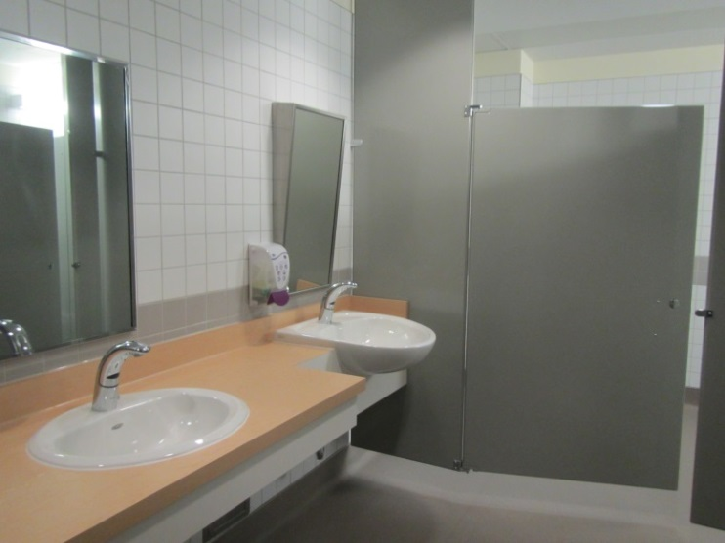
- Large accessible washrooms that facilitate manoeuvrability
- Automatic door openers
- Automatic flush
- Counter cut-outs
- Wide doors
- L-shaped grab bars.
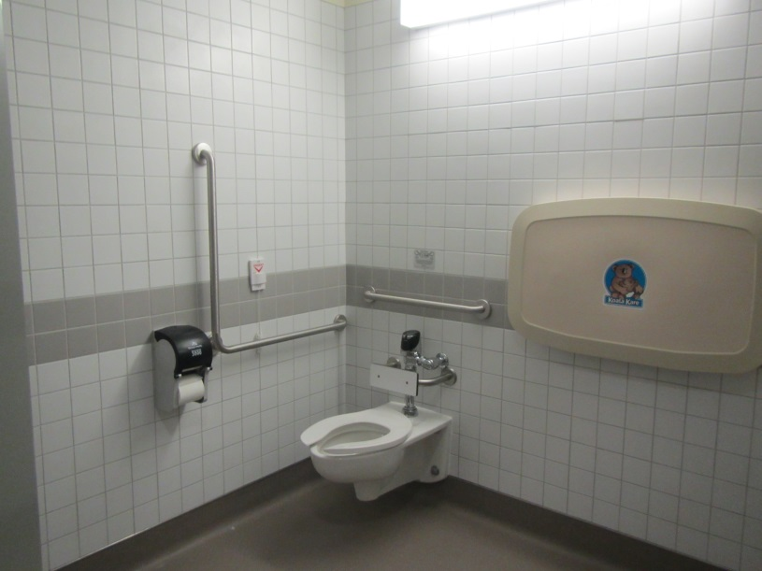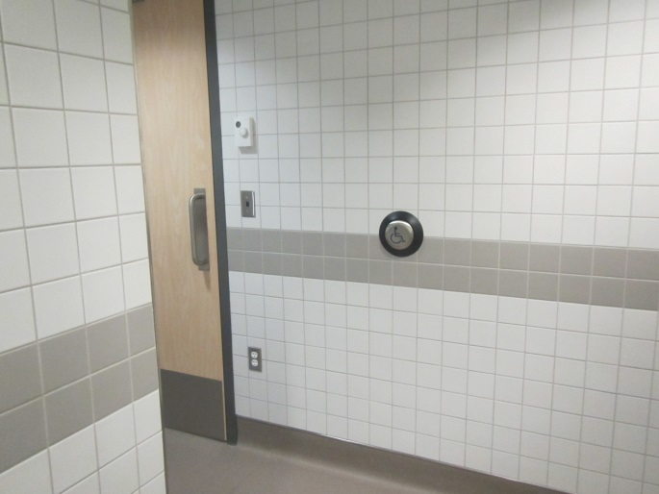
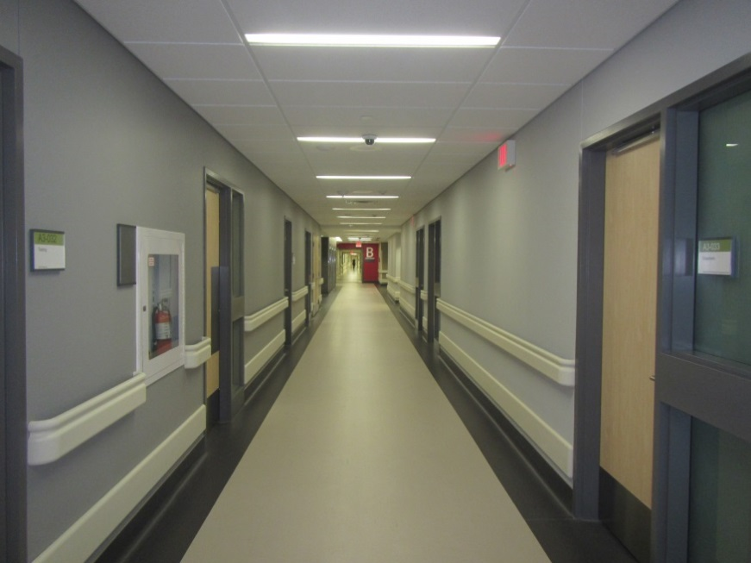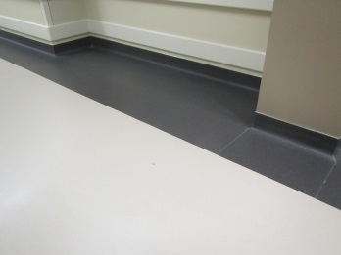
- Wide uncluttered corridors
- Colour contrasting door frames
- Colour contrasting floor, baseboard and walls
- Handrails
- Small alcoves for equipment placement

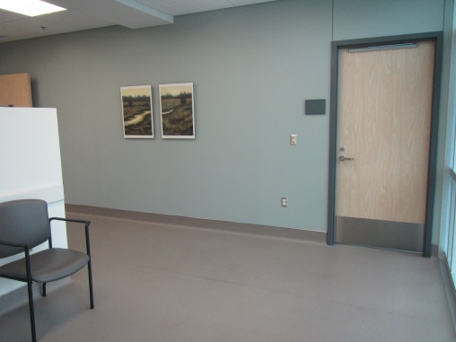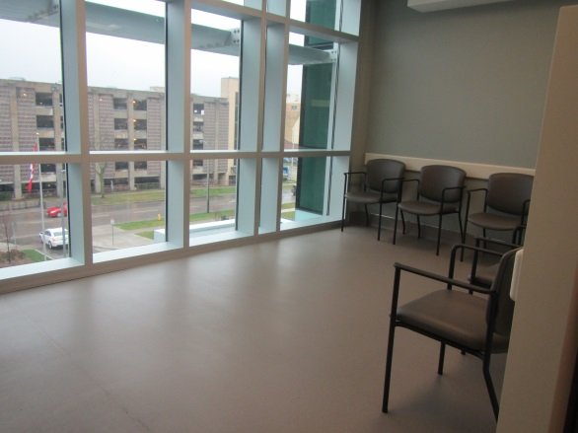
- Large accessible waiting area in Human Resources
- Colour contrasting door frames
- Wide doors with levered handles
- Sturdy arm chairs
- Ample natural light
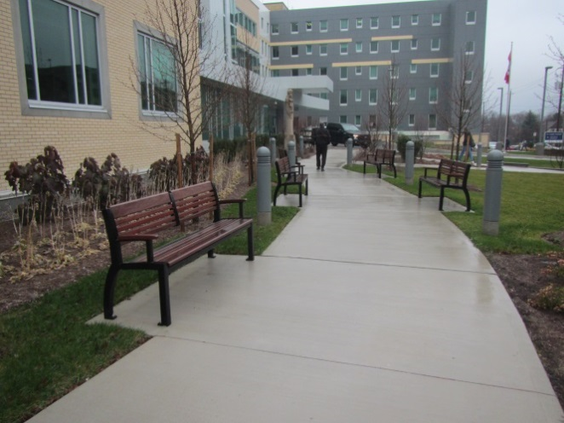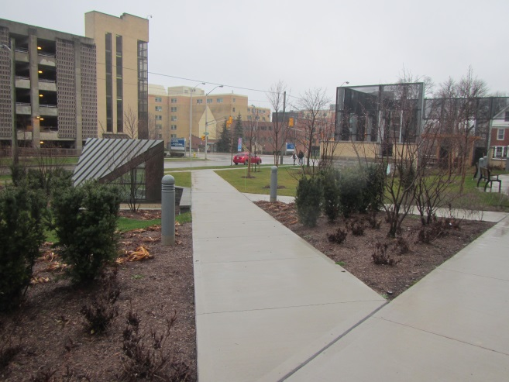
- Landscaping with gently graded sidewalks
from the street and throughout the garden
- Wide sidewalks
- Benches offset from sidewalks
- Large manoeuvrable area in the pagoda
- Lighting along sidewalks
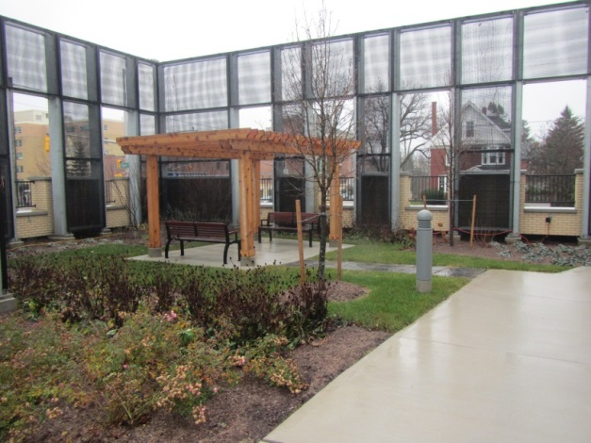

Review and monitoring process
The Accessibility Advisory Committee meets four to seven times a year. Subcommittees may form to address one or more barriers. At each meeting, subcommittees report to the Accessibility Advisory Committee on their progress in implementing the plan. The chair of the Accessibility Advisory Committee or the vice president presents the plan or annual status report to senior leaders.

Communication of the plan
Once approved, the Accessibility Plan and subsequent status reports are posted to St. Joseph’s Accessibility Website and staff is notified through the electronic newsletter E-Print. Hard copies are available in staff libraries at each site and from Communication and Public Affairs. Reports and plans are available in accessible formats upon request.

