
EMPLOYEE PERSONAL DATA FORM
Confidential Information – For People Services Purposes Only

PERSONAL DATA

Mr Mrs Miss Ms Dr Employee ID

Last Name First Name

Middle Name or Initial Gender Male Female

Social Insurance # (SIN) _ _ _ / _ _ _ / _ _ _ Birth Date _ _ _ _ / _ _ / _ _

Y Y Y Y M M D D

ADDRESS/PHONE

Apt/Street

City/Province Postal Code

Home Phone # Other Phone # Cell Other

EMERGENCY CONTACT

Name

Home Phone # Other Phone # Cell Other

Relationship to you

BANKING INFORMATION
(Line of Credit Accounts cannot be Used)

Bank Name:
Bank Address or Intersection:
City/Town: |  | Province: |  | Postal Code:
3-digit Institution Number: | 5-digit Branch Number: |  | Account Number:
*** Please attach a Cheque marked “VOID” *** or
Direct Deposit Form from your financial institution

The following numbers can be found in your passbook, on your bank statement, encoded deposit slip, or cheque (sample below); or, by contacting your financial institution. Note, most financial institutions will not allow payroll deposit to your Line of Credit account.

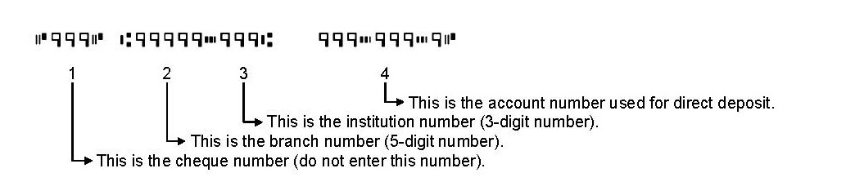

Employee Signature Date

