Corporate Account, and System Access

Please review this entire document and then follow all the steps below to set up your:
- Corporate ID (network account)
- Outlook (email account)
- Remote Access
- Beep! (instant messaging)
 | Purpose: | How To:
Corporate ID: | Your Corporate ID will allow access to the following applications:  - Outlook (Email)  - OneChart (EHR - Cerner)  - ePay  - (ME) MyEducation (eLearning modules)  - Intranet  - NetScaler remote access  Your Corporate ID will enable access to hospital computers and desktops, which include productivity tools such as Microsoft Word, Microsoft Excel, and applicable department drives where items such as call schedules are posted.  Corporate ID:  <LOGIN>  Temporary Password:  (case sensitive)  <PASSWORD>  Email Address:  <EMAIL>  Employee ID  <ID>  Schulich ID  <ID> | Change your Temporary Password:  Please change your Corporate ID password  Important Note: You must change your password before you access your ME (My Education) account to complete the eLearning modules and register for in class training.  Forgot your Password? Contact the ITS Help Desk at 4-HELP (519-685-8500 x44357)  You may be asked to provide one of the following identifiers, along with your full name and day / month of birth:  - Western Student Number  - Hospital employee ID  - OHIP billing number  - Schulich ID number
Outlook Email Account | You are required to access your Outlook email regularly.  Information relevant to your practice as a physician in our hospitals will only be sent to your secure Outlook email account further to hospital policy.  Failure to monitor this email may result in missed information relating to the maintenance of your hospital privileges. | Accessing Outlook From Home:  Set up Duo multi-factor authentication (MFA) at https://mfa.lhsc.on.ca  Access Outlook from a computer external to the hospital by visiting https://office.com  You will need to log in with your Corporate ID and password.  Step-by-step documentation for Duo  Additional educational resources from Information Technology Services (ITS)  Accessing Outlook from the Hospital:  Click on Start > All Programs > Microsoft Office > Outlook to launch Outlook on a hospital PC or Laptop, or on the Desktop of any hospital Thin Client.
Forward Western Email to hospital Outlook Email  (HIGHLY RECOMMENDED) | The hospital Outlook email system is a secure, private and confidential mode of information transmission. Confidential or sensitive business or identifiable patient or staff/affiliate information must not to be transmitted by email external to the secure email systems of the hospitals.  The secure system is comprised of London Health Sciences Centre (@lhsc.on.ca) and St. Joseph’s Health Care London (@sjhc.london.on.ca), HMMS (@hmms.on.ca) and Lawson Research (@lawsonresearch.com)  PLEASE NOTE: Your Western email account (@uwo.ca) is outside the secure system. In order to minimize the number of accounts you need to manage, you can forward other accounts to your hospital Outlook email account, however, please recognize that you cannot forward your Outlook email account to another account. | Instructions to forward @uwo to Outlook
Beep! Urgent Messaging System | LHSC and St. Joseph's has moved to a new citywide urgent messaging solution system called Beep!. This will eventually replace the more traditional pocket pagers used in healthcare and works with many devices including smart phones, wireless IP phones, and instant messaging products.  All Professional Staff, Residents, and Clinical Fellows are automatically set up with a Beep account.  To login into Beep, you will need to use your Corporate ID and Password. | View the Information Technology Services (ITS) website for information on how to set your Beep account up.
ME(MyEducation)  Required eLearning | ME is a learning management system that features a catalogue of eLearning modules which are available 24 hours a day, seven days a week.  This system allows you to access your required hospital eLearning (Certifications), and provides you the opportunity to register for various training sessions, and view optional eLearning. | Please make sure your eLearning (required by legislation, ministry orders, and hospital policy) are all completed and up to date.  Sign into ME(MyEducation) with your Corporate Username and Password.  On the ME home page, the eLearning (Certifications) that you will be required to complete will be listed on the home page in the area called "Current Learning".  Beside the name of the Certification, click "Begin Registration" and then on the next page click on "Complete Registration" to launch the eLearning. A separate window will open with the eLearning content; follow the instructions within.  Modules will average approximately 15 minutes each to complete
Other Recommended eLearning | For anyone using their cell phone for Beep! instant messaging, it is recommended to complete the “How to use Beep!” eLearning module | Once logged on to ME, select "Browse” then “Browse Catalogue" (top of page).  All other optional eLearning can be found under the heading “5. Discretionary eLearning” by clicking on “All Optional Corporate and Clinical eLearning”
NetScaler Remote Access | You will be granted remote access, which will allow you to have access to Cerner and other hospital systems from a non-hospital computer. The software to achieve this is called NetScaler.  An email will be sent to your hospital Outlook email account providing instructions on how to access this system.  Sign in with your Corporate ID and password. | Support is available from the HelpDesk at 519-685-8500 x44357 Monday to Friday from 0800-1600. Outside of these hours, support is limited to basic troubleshooting and password resets.  Remote access is available to Clinical Staff to assist with on-call activities, but should not be relied upon as a replacement for on-site visits if necessary due to issues with functionality on a personal device.
Wireless (WiFi) Access | Eduroam or education roaming, provides roaming wireless network access for students, staff and faculty at partner institutions. | In order to connect to the eduroam network, choose “eduroam” from your list of available wifi networks.  When logging into eduroam, users must enter their email address (user@uwo.ca) and password from their home institution. Any issues connecting should be directed to your home institution, not to the hospital Help Desk.  Review more information about wifi at the London hospitals.
City Wide ITS Help Desk for London hospitals | 4-HELP or 519-685-8500 x44357 | Help Desk Support Specialists are available to assist you 24/7/365.

Onboarding Tasks

Other onboarding tasks such as Parking, Dictation Code, and Scrub Cards can be found on the Preparing for your first day website

ME(MyEducation) Requirements and PowerChart Training

ME is a learning management system that features a robust, continuously expanding catalogue of eLearning modules which are available 24 hours a day, seven days a week. This system allows you to access your required hospital eLearning (Certifications), and provides you the opportunity to register for various in class training sessions, and view optional eLearning.
Sign into ME(MyEducation) with your Corporate Username and Password

In this system you will need to complete (in this order):
- Cerner PowerChart eLearning
- Register for In class simulations
- Required hospital and legislative eLearning Modules
- Registrations for N95 Respirator Fit Testing

NOT REQUIRED FOR WINDSOR RESIDENTS
Step 1: Cerner PowerChart eLearning
If you have any difficulties with the eLearning especially using Chrome please see below (page3) for step by step instructions
The Provider PowerChart simulations within MyEducation offer a variety of learning activities, organized into multiple simulations. The simulations provide end-to-end, role-based scenarios and activities to assist the learner in gaining confidence and competence within the OneChart applications. The learner must complete each simulation before moving on to the next.
- Once logged in to ME, select "Browse” then “Browse Catalogue" (top of page)
- Under the heading Professional Staff (Physicians, Dentists and Midwives):
- Select “Electronic Health Records Orientation”
- On the next page, click "MA Electronic Health Record (EHR) eLearning" then "Register” and the eLearning will then launch. The eLearning will take you up to 2 hours to complete
Simulation 1: Navigate/Review a patient’s chart  - View Chief Complaint  - View Documents  - View Lab results  - Identify PowerPlans | Simulation 2: Admit a patient from the ED  - Document a BPMH  - Add Admit TO Inpatient order  - Complete admission order reconciliation  - Add Resuscitation Status Careset order  - Add admission PowerPlan  - Initiate PowerPlan
Simulation 3: Round on a patient  - Add single orders using Quick Orders  - Modify orders  - Learn where to find Nursing documentation | Simulation 4: Discharge a patient home  - Add discharge order  - Complete discharge order reconciliation  - Add follow-up appointment order  - Create discharge note with ACN
Simulation 5: Work with Message Center  - An introduction to the Message Center  - Modify a document  - Refuse a document  - Approve an order  - Sign a proposed order | Simulation 6: Work in an ambulatory clinic  - Open a clinic schedule  - Open a patient chart by searching  - Add a recurring PowerPlan  - Complete an outpatient discharge reconciliation  - Review and print an Outpatient Visit Summary

Step 2: In Class Training
After the simulations have been completed, you will be asked to click on a link to go to the registration page and register for a mandatory In Class session. This will provide you the opportunity to practice the skills you have learned using a workbook of activities developed by the Learning Services Team. If there are no in class sessions listed please contact Jennifer Joyce to do remotely

Step 3. Required hospital and legislative eLearning Modules:
On the ME home page, the eLearning that you need to complete will be listed in the area called "Current Learning".
- Beside the name of the course, click "Begin Registration" and then on the next page click on "Complete Registration" to launch the eLearning. A separate window will open with the eLearning content; follow the instructions within.
- Modules will average approximately 15 minutes each to complete and are mandated by legislation or hospital policy.

Step 4. N95 Respirator Fit Testing
- N95 Mask Fit sessions will be by registration in ME
- Under the heading Professional Staff (Physicians, Dentists and Midwives):
- Select “Respirator Fit Testing “
- Select Register for the date and time that works for you

For assistance navigating ME(MyEducation) please contact 519-685-8500 x 75911 M-F 830-1630 or email jennifer.joyce@lhsc.on.ca

Step by Step Instructions for using Chrome for PowerChart eLearning Simulations
- From the Home page of My Education, click the down-arrow beside Browse and select Browse Catalog.
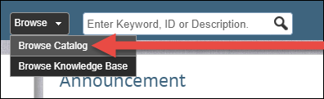

- Under the 2020 New Resident and Fellows category, click PowerChart (Electronic Health Record) Orientation-New trainees.
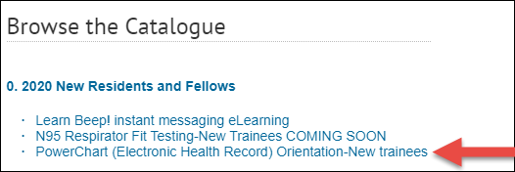
- Under Learning Offerings, click MA Electronic Health Record (EHR) eLearning – Trainees.
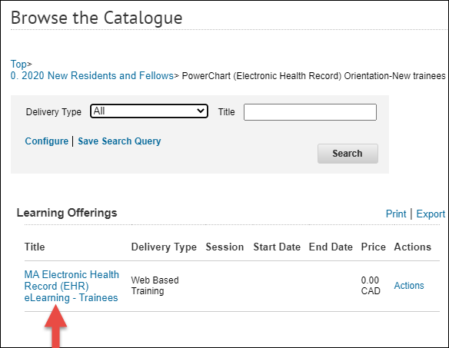
- From the next screen that opens, click the Register and Launch button.
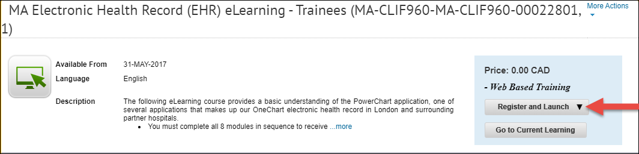

The first module opens.
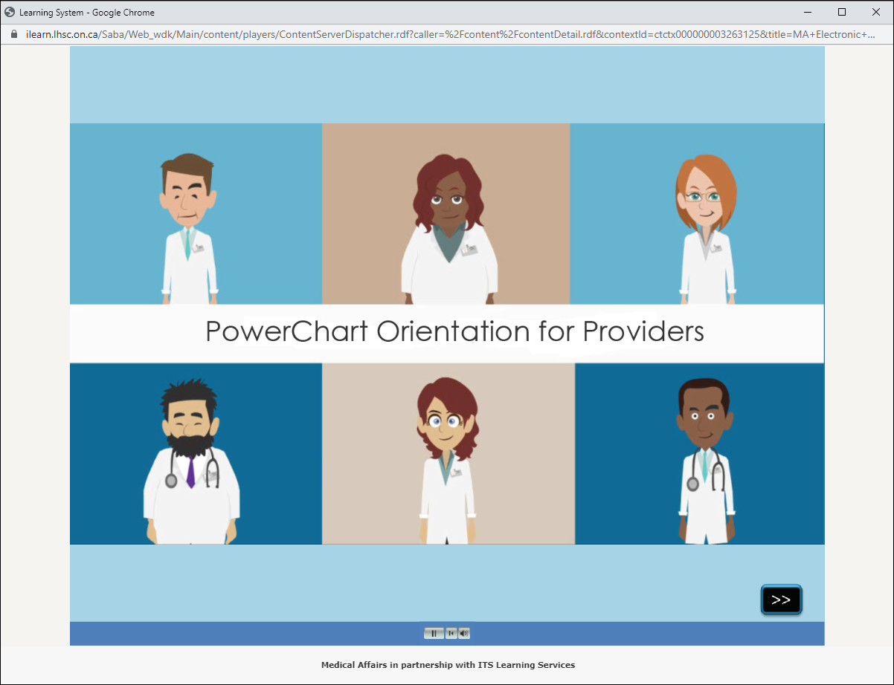
- Complete the module.

At the end of each module, there is a completion screen.
- You must click the Mark Complete button.
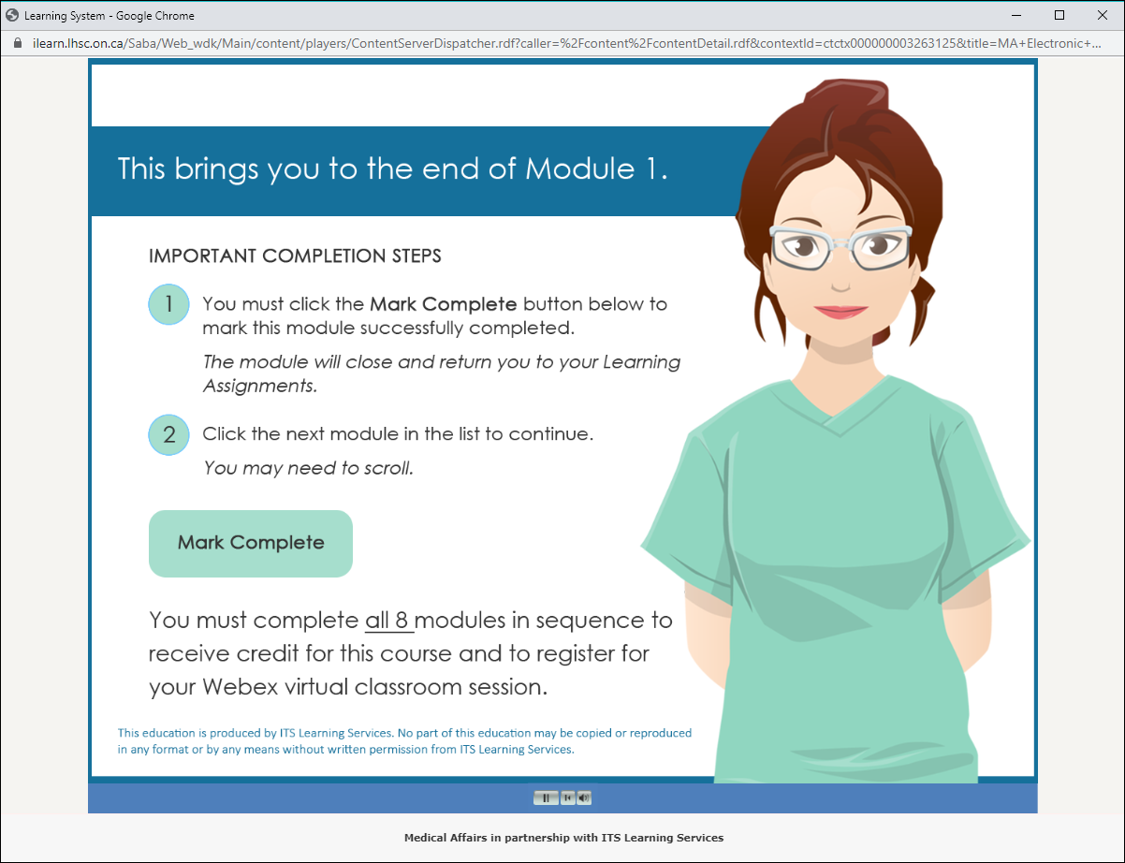
You’ll be returned to your Learning Assignments.
- The previous module is marked successful and the Launch button appears for the next module in sequence.
KNOWN COMPLETION ISSUE WITH CHROME BROWSER
In Chrome, the module you just completed will remain in a completion status of Not Evaluated and the Launch button will not appear for the next module in sequence.
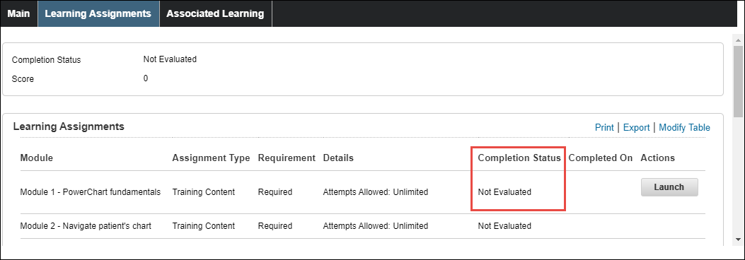
COMPLETION FIX IN CHROME BROWSER
- You must click the Main tab and then click back on the Learning Assignments tab.
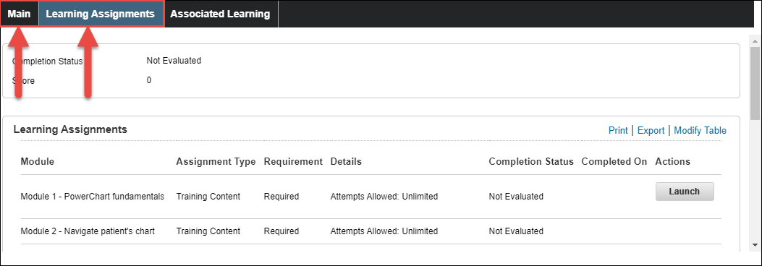
Once you do that, the previous module is marked as Successful and the Launch button appears for the next module in sequence.
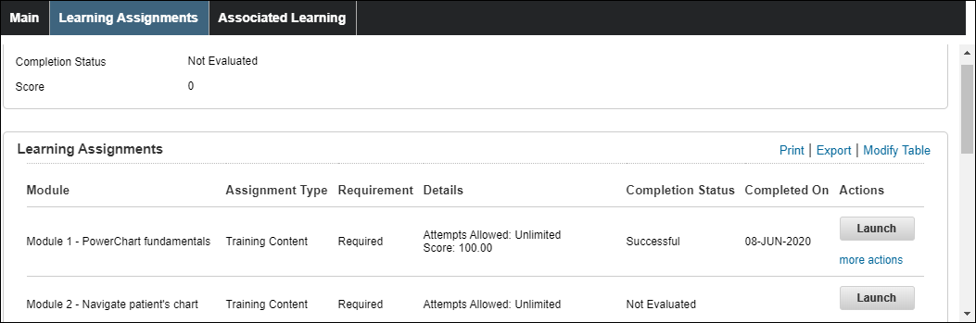

RELAUNCHING LEARNING ASSIGNMENTS
If you don’t have time to complete all eight (8) modules in one viewing, the next time you login to My Education, you’ll see the course under Current Learning.
- Do NOT click the Launch link – this launches the first module in the sequence (Module 1).
- Instead, click the title of the course.
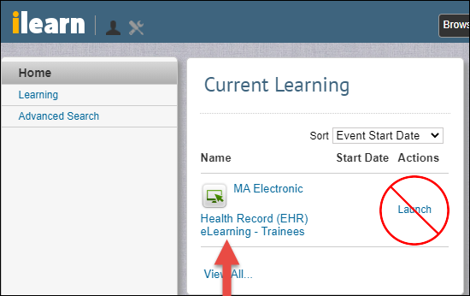
This opens the Learning Assignments page.
- You can click the Launch button to open the next module in the sequence.
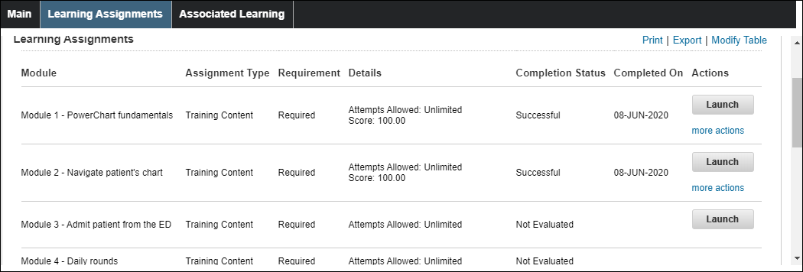
Remember you may need to scroll to see all the modules.

