Corporate Account, and System Access

Please review this entire document and then follow all the steps below to set up your:
- Corporate ID (network account)
- Outlook (email account)
- Remote Access
- Beep! (instant messaging)
 | Purpose: | How To:
Corporate ID: | Your Corporate ID will allow access to the following applications:  - Outlook (Email)  - OneChart (EHR - Cerner)  - (ME) MyEducation (eLearning modules)  - Intranet  - Horizon remote access  Your Corporate ID will enable access to hospital computers and desktops, which include productivity tools such as Microsoft Word, Microsoft Excel, and applicable department drives where items such as call schedules are posted.  Corporate ID:  <LOGIN>  Temporary Password:  (case sensitive)  <PASSWORD>  Email Address:  <EMAIL> | Change your Temporary Password:  Please change your Corporate ID password  Important Note: You must change your password before you access your ME (My Education) account to complete the eLearning modules and register for in class training.  Forgot your Password? Contact the ITS Help Desk at 4-HELP (519-685-8500 x44357)  You may be asked to provide one of the following identifiers, along with your full name and day / month of birth:  - Western Student Number  - Hospital employee ID  - OHIP billing number  - Schulich ID number
Outlook Email Account | You are required to access your Outlook email regularly.  Information relevant to your practice as a physician in our hospitals will only be sent to your secure Outlook email account further to hospital policy.  Failure to monitor this email may result in missed information relating to the maintenance of your hospital privileges. | Accessing Outlook From Home:  Set up Duo multi-factor authentication (MFA) at https://mfa.lhsc.on.ca  You must enroll with LHSC DUO multi-factor authentication even if you have already done this with Western.  Access Outlook from a computer external to the hospital by visiting https://office.com  You will need to log in with your Corporate ID and password.  Step-by-step documentation for Duo  Additional educational resources from Information Technology Services (ITS)  Accessing Outlook from the Hospital:  Click on Start > All Programs > Microsoft Office > Outlook to launch Outlook on a hospital PC or Laptop, or on the Desktop of any hospital Thin Client.
Forward Western Email to hospital Outlook Email  (HIGHLY RECOMMENDED) | The hospital Outlook email system is a secure, private and confidential mode of information transmission. Confidential or sensitive business or identifiable patient or staff/affiliate information must not to be transmitted by email external to the secure email systems of the hospitals.  The secure system is comprised of London Health Sciences Centre (@lhsc.on.ca) and St. Joseph’s Health Care London (@sjhc.london.on.ca), HMMS (@hmms.on.ca) and Lawson Research (@lawsonresearch.com)  PLEASE NOTE: Your Western email account (@uwo.ca) is outside the secure system. In order to minimize the number of accounts you need to manage, you can forward other accounts to your hospital Outlook email account, however, please recognize that you cannot forward your Outlook email account to another account. | Instructions to forward @uwo to Outlook
Beep! Urgent Messaging System | LHSC and St. Joseph's has moved to a new citywide urgent messaging solution system called Beep!. This will eventually replace the more traditional pocket pagers used in healthcare and works with many devices including smart phones, wireless IP phones, and instant messaging products.  All Professional Staff, Residents, and Clinical Fellows are automatically set up with a Beep account.  To login into Beep, you will need to use your Corporate ID and Password. | View the Information Technology Services (ITS) website for information on how to set your Beep account up.
Horizon Remote Access | You will be granted remote access, which will allow you to have access to Cerner and other hospital systems from a non-hospital computer. The software to achieve this is called Horizon. | As of October 1, 2021, London Health Sciences Centre and St. Joseph’s Health Care London will no longer use Citrix NetScaler for remote access. In order to access your applications from offsite, you will need to use VMware Horizon and Duo (for multi-factor authentication).  Please login with the instructions below as soon as possible to avoid a disruption of service.  To access VMware Horizon remotely:  - Set up multi-factor authentication with DUO  If you’ve already done this for other hospital systems (e.g. Office 365 or MyHR), move to the steps below  - Visit https://login.lhsc.on.ca  - Use Horizon:  - on the web by clicking on VMware Horizon HTML Access, or  - install the VMware Horizon Client*  *If you use Horizon at another organization and already have the Horizon client installed, you may be able to add the hospital server by clicking +new server and typing the server name login.lhsc.on.ca.  Visit the Education and resources intranet page for more detailed instructions and other information about Horizon.
Wireless (WiFi) Access | Eduroam or education roaming, provides roaming wireless network access for students, staff and faculty at partner institutions. | In order to connect to the eduroam network, choose “eduroam” from your list of available wifi networks.  When logging into eduroam, users must enter their email address (user@uwo.ca) and password from their home institution. Any issues connecting should be directed to your home institution, not to the hospital HelpDesk.  Review more information about wifi at the London hospitals.
City Wide ITS Help Desk for London hospitals | 4-HELP or 519-685-8500 x44357 | HelpDesk Support Specialists are available to assist you 24/7/365.
ME(MyEducation)  Required eLearning | ME is a learning management system that features a catalogue of eLearning modules which are available 24 hours a day, seven days a week.  This system allows you to access your required hospital eLearning (Certifications), and provides you the opportunity to register for various training sessions, and view optional eLearning. | Please make sure your eLearning (required by legislation, ministry orders, and hospital policy) are all completed and up to date.  Further instructions on Page 5

Onboarding Tasks
Other onboarding tasks such as Parking, Dictation Code, and Scrub Cards can be found on the Preparing for your first day website
________________________________________________________________________________________________
Cerner PowerChart Training
This training is a requirement prior to starting and will be completed remotely through the Cerner Learning portal.
You will receive an automated email when the journey has been assigned to you from Learning Portal (noreply@mail.cerner.com) to your HOSPITAL EMAIL. Please ensure your hospital email has been set up. You will receive a second email with login instructions to access the Cerner Learning portal, this email will be sent from Inservice Registration inservice.registration@SJHC.london.on.ca .
The journey is comprised of individual activities that you must complete. It may take up to 4 hours to complete the journey, however it is not necessary to complete all activities at once. Important to note that if you exit before completing an individual activity, when you return you will need to start the activity from the beginning. Please see Page 5 with Learning Journey Login Tips.

ME(MyEducation) Requirements and PowerChart Training
ME is a learning management system that features a catalogue of eLearning modules, courses and training which are available 24 hours a day, seven days a week.
Sign into ME(MyEducation) via hospital Corporate ID and Password.
Required Hospital and legislative eLearning Modules:
- Sign into ME
- On the ME home page, the required eLearning is listed on the home page in the area called "Current Learning".
- Beside the name of the course, click "Launch" to begin the eLearning. A separate window will open with the eLearning content; follow the instructions within.
- Modules will average approximately 15 minutes each to complete and are mandated by legislation or hospital policy.
N95 Respirator Fit Testing
Masks carried by the hospital are 1860, 1860S, 1804 and 1870+.
If not fitted to one of these mask types, please get refitted.
- After receiving a Corporate ID, N95 Mask Fit sessions will be by registration in ME
- Sign into ME, click Browse Catalog at the top of the page
- Under the heading Professional Staff (Physicians, Dentists and Midwives):
- Select “Respirator Fit Testing
- Select Register next to the session with the desired date and time
Please arrive 5 minutes early to your appointment. Please read the Fact Sheet and complete the Screening Form attached to your appointment before arriving.
For assistance navigating ME(MyEducation) please contact Cassandra Fullager

See Cerner PowerChart Learning Portal Tips on the next page

Learning Portal Tips

Open Google Chrome or Microsoft Edge
- Open Microsoft Edge.
Important: Do not use Internet Explorer!
- In the address bar in Microsoft Edge type lhsclearn.cerner.com
The login screen of the learning portal opens.

First time login
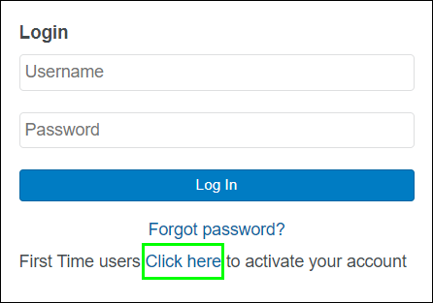
- You must create a new password the first time you login. Click Click here.
- Type your corporate username (the same one you use for PowerChart), then click Submit.
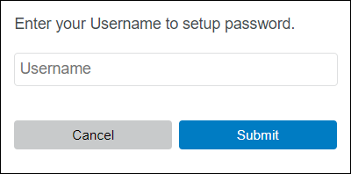

Learning Portal Tips
Important: If you are unable to login at this point please let your clinical lead or a clinical educator know ASAP.
- Follow the prompt to change your password
- The next time you login, use your new password.

Portal dashboard and launching the journey
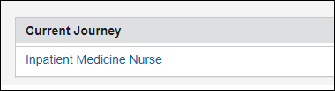
After login, the portal dashboard opens and you will see the journey that you have been assigned.
If you’ve been in the journey before, the dashboard gives a status of journey’s progress.
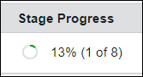
1. Click the name of the journey to open the journey, which is organized in stages.

Working through the learning journey stages
You must complete the stages in sequence.
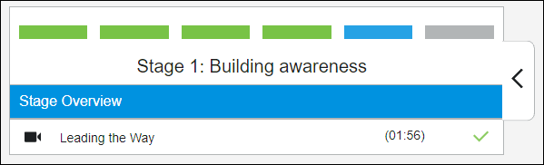
As you complete an activity in a stage, a green check mark ( ) appears to the right of that activity.
You must complete all activities in a stage before the portal moves you to the next stage in your journey.
On the last slide of each simulation, you must click the Exit button to exit the simulation successfully and return to your activities.
If you just click the X in the browser window, you will not be marked successful and will have to repeat the activity.

Learning Portal Tips

Access portal from home
If you are working on your learning journey at home, ensure you are not using Internet Explorer as your browser.

Access portal from a thin client device in the hospital
If you are working on your learning journey here at the hospital, follow these directions to access and complete journey and avoid technical issues. If you need you can call Helpdesk @ 4HELP.
How do I know I’m using a thin client?
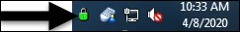
In the bottom right-hand corner of your screen in the System Tray you will see a small green padlock icon if your computer is a thin client.
WOWs are thin clients.
Important: Do NOT access a web browser directly from the thin client desktop.
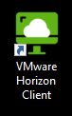
- Navigate to VMware Horizon Client.
- Click the Login icon.
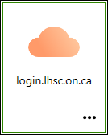
The login window opens.
- Enter your corporate username and password and click Login
- Enter the passcode from the Duo application on your phone.
The storefront window opens.

Learning Portal Tips
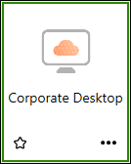
- Click the Corporate Desktop icon.
The Corporate Desktop opens.
- Open Microsoft Edge as your browser.

Date: May 24, 2022 Page | 1 of 4

Learning Portal Tips

